Lab Assignment 3

# **Ques 1.** Write a shell script to input 2 integer number and perform all its arithmetic operation.

echo "Enter the first number: "

read n1

echo "Enter the second number: "

read n2

s=`expr $n1 + $n2`

echo "Sum: $s"

sub=`expr $n2 - $n1`

echo "Subtraction: $sub"

p=`expr $n1 \* $n2`

echo "Product: $p"

d=`expr $n2 / $n1`

echo "Division: $d"

m=`expr $n1 % $n2`

echo "Modulus: $m"

# Output

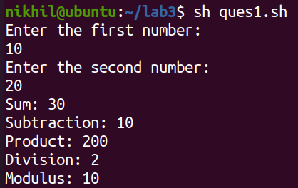

# **Ques 2.** Write a shell script to input time in sec and find out how many hours, mins and secs are there.

echo "Enter the time in seconds"

read s

hours=`expr $s / 3600`

d=`expr $s % 3600`

min=`expr $d / 60`

sec=`expr $d % 60`

echo "HH:MM:SS "

echo "$hours:$min:$sec"

# Output

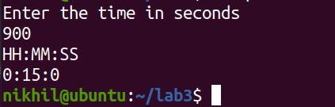

# **Ques 3.** Write a shell script to input 2 sides of rectangle and find it’s area.

echo "Enter length and breadth of rectangle:"

read l

read b

area=`expr $l \* $b`

echo "Area of rectangle = $area"

# Output

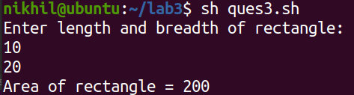

# **Ques 4.** Write a shell script to input a 3 digit number and find out the sum of all digits.



echo "Enter a 3-digit number: "

read n

temp=$n

val=`expr $temp % 10`

sum=$val

temp=`expr $n / 10`

val=`expr $temp % 10`

sum=`expr $sum + $val`

temp=`expr $temp / 10`

val=`expr $temp % 10`

sum=`expr $sum + $val`

echo "Sum of the three digits = $sum"

# Output

# **Ques 5.** Write a shell script to input a 2 numbers and swap them.

echo "Enter the two numbers to be swapped: "

read a

read b

echo "Values of a = $a and b = $b (before swapping)"

c=$a

a=$b

b=$c

echo "Values of a = $a and b = $b (after swapping)"

# Output

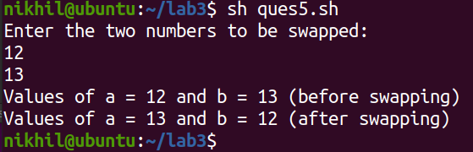

# Without using third variable.

echo "Enter the two numbers to be swapped: "

read a

read b

echo "Values of a = $a and b = $b (before swapping)"

a=`expr $a + $b`

b=`expr $a - $b`

a=`expr $a - $b`

echo "Values of a = $a and b = $b (after swapping)"

# **Ques 6.** Write a shell script to find greatest and smallest no.

echo "Enter the two numbers : "

read a

read b

if [ $a -gt $b ]

then

echo "$a is the greatest and $b is the smallest"

else

echo "$b is the greatest and $a is the smallest"

fi

# Output

# 

# **Ques 7.** Write a shell script to check equal to or greater among 2 nos.

echo "Enter the two numbers: "

read a

read b

if [ $a -eq $b ]

then

echo "The numbers are equal"

else

    if [ $a -gt $b ]

    then

    echo "$a is the greatest and $b is the smallest"

    else

    echo "$b is the greatest and $a is the smallest"

    fi

fi

# Output

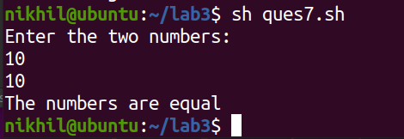

# **Ques 8.** Write a shell script to find the square of a number if it is positive and cube if it is negative.

echo "Enter a number: "

read a

if [ $a -lt 0 ]

then

echo "The number is negative ($a)"

a=`expr $a \* $a`

echo "The square of number is (-$a)"

else

echo "The number is positive"

a=`expr $a \* $a \* $a`

echo "The cube of number is $a"

fi

# Output

